The Impulse to Scribble:
On Liu Chuang’s Love Story at Salon 94
Liu Chuang: Love Story
Freemans Space, Salon 94 Gallery, New York
May 7 - June 21, 2014
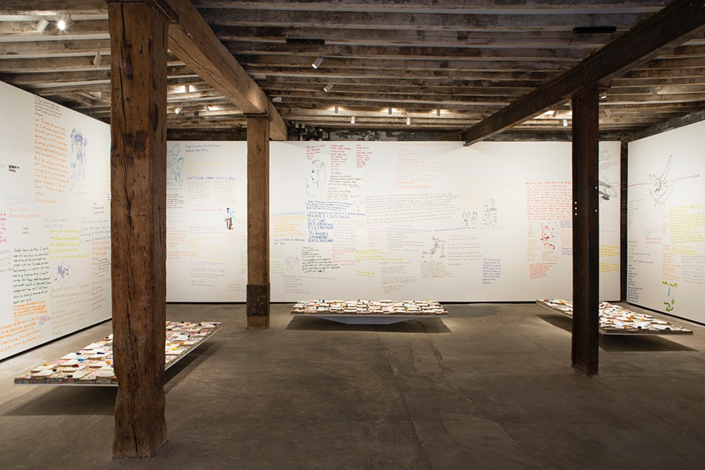
Liu Chuang, Love Story , Salon 94 Gallery, New York
“To know that one does not write for the other, to know that these things I am going to write will never cause me to be loved by the one I love (the other), to know that writing compensates for nothing, sublimates nothing, that it is precisely there where you are not – this is the beginning of writing.”
— Roland Barthes¹
Roland Barthes’ A Lover’s Discourse: Fragments does not pertain to a specific set of lovers, similarly, Liu Chuang’s Love Story does not pertain to any specific love story; with these puzzling titles, the two speak of matters which at first appear similar, but are in fact otherwise. Barthe writes of language and lust, while Liu Chuang’s exhibition involves “the impulse to scribble”.
The difference between writing and scribbling is this: the former hints at some sort of cohesion and achievement, while the latter emphasizes the act of writing itself. Liu Chuang collected thousands of pulp romance novels from the latter part of the 21st century and early part of the new millennium. These novels were passed between blue-collar workers, with most readers being female workers from the manufacturing industry. The artist sorted through these novels as if searching for buried treasure, seeking notes left on the margins by their readers. His search rewarded him with emotional sentiment, poetry, first drafts of letters, running accounts, reminders, QQ account numbers, doodles, addresses… Though the artist attempted to file the notations he found into six major categories, a great portion of the marks left in the books defied categorization and were simply remnants of recorded motion. Some pages were obviously used to jot down existing text (receipts and advertisements), while others were probably used by the writer to practice her handwriting, still others were indecipherably mysterious symbols or phrases, their ambiguity perhaps the writer’s intent.
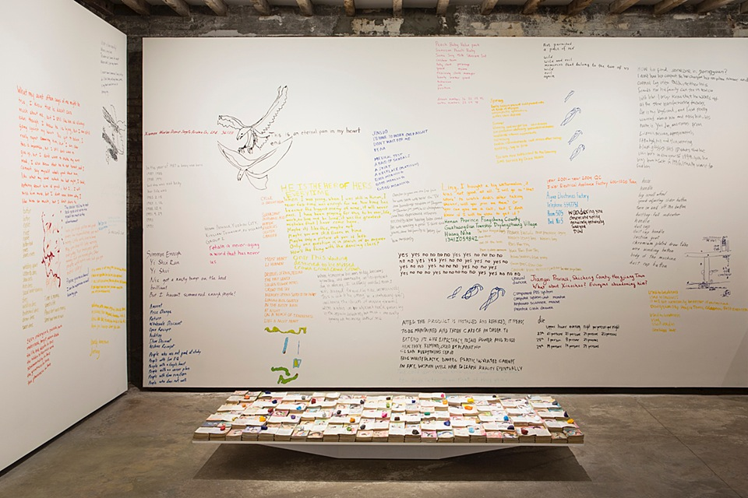
Liu Chuang’s Love Story On-site at Salon 94
Love Story is being exhibited at Salon 94 Freemans, located next to the New Museum of Contemporary Art in New York. The space is situated in a small alleyway somewhat analogous to where the artist originally found these romance novels. Liu Chuang purchased the pulp novels from small, nearly bankrupt bookstores located near factories in Dongguan. These books originated in Hong Kong and Taiwan, and later became recreational media for the emerging class of the Mainland’s economic transformation. Now, they have been shipped overseas by air to New York – the global capital of the free market. Besides the thousands of neatly arrayed books that form the exhibition’s main installation, site-specific pieces include the English translations of the message, as well as doodles which have been copied onto the walls of the gallery by staff and friends wielding multicolor markers. The walls of this white box space have been set alight by the revelation of these subtle secrets.
These anonymous writers know the wandering nature of borrowed books, the range of visibility of the traces they leave in them, and the single directionality of the markings. These talented and/or directionless readers are the co-creators of this art work. From novels which lack significance in and of themselves, they have reclaimed a large expanse of space. An empty concrete lot may seem barren and pallid, but it holds limitless possibilities. The artist reminds us: the popularity of online platforms like forums and blogs has increased rapidly, while paperback books have vanished from the market due to the widespread use of the smart phone. Perhaps there is a larger impulse behind the urge to scribble that is also relevant to the times. By engaging in postprocessing of products from the cultural market which have already been “processed” by their users, Liu Chuang is revealing or directly participating in the social relations of production. Nicolas Bourriaud puts forth, “Art tends to give shape and weight to the most invisible processes”, describing a trajectory in the cultural landscape, and constructing a linkage between forms, signs, and images via this “post-production” method of creation.²
The impulse to scribble arises from speechlessness. When an outpouring of energy seeks, but finds no quarter, it is relegated to the pages of a book that happens to be resting in one’s pocket, and those pages becomes a resting place for that ghost of a thought. Love Story exhibits those muted words, and gives them a voice with which to shout – a shout that thunders in the ears of its audience. An analogous work is Liu Chuang’s 2010 video work, Untitled (Dance Partner), which films two automobiles of the same make and model driving side by side at minimum speed on a city highway. Without violating any traffic regulations, the experiment resulted in small-scale confusion of the senses and reality, quietly questioning and destroying seemingly solid constructs in the dark of the night. Of Liu Chuang’s works, the quietest, smallest, and slowest are often the most powerful elements. Some call Liu Chuang an interloper, Liu himself says he acted as an archaeologist in “Love Story”, but in my eyes, he is a dialectician.
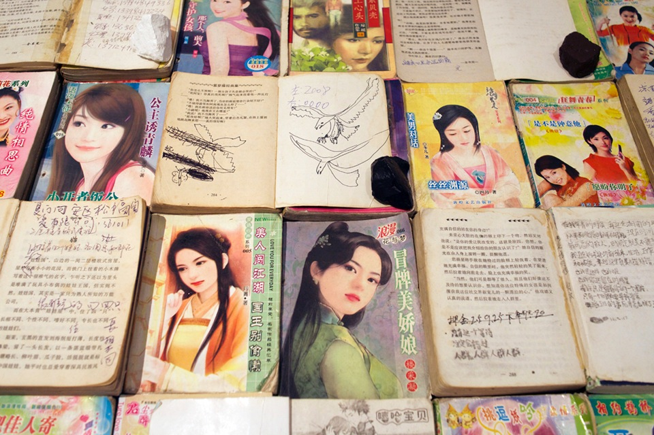
Details of Liu Chuang, Love Story, Salon 94 Gallery, New York

Footnotes:
1. Roland Barthes. A Lover’s Discourse: Fragments, Shanghai People’s Publishing House. 1988 First Edition. Page 100.
2. Nicolas Bourriaud. Postproduction, Gold Wall Press. 2014, II, Page 25.

